============================================================

SET 4

Q1. (Algorithms – 5 Marks)
Use AI to generate Python code that finds the minimum and maximum in an array using the divide and conquer approach.
Test with a 12-element list.

Q2. (Frontend – 5 Marks)
With AI assistance, generate a webpage containing an image gallery arranged in a 3-column responsive grid.
Add JavaScript for image enlargement on click.
=====================================================================
TASK 1 :
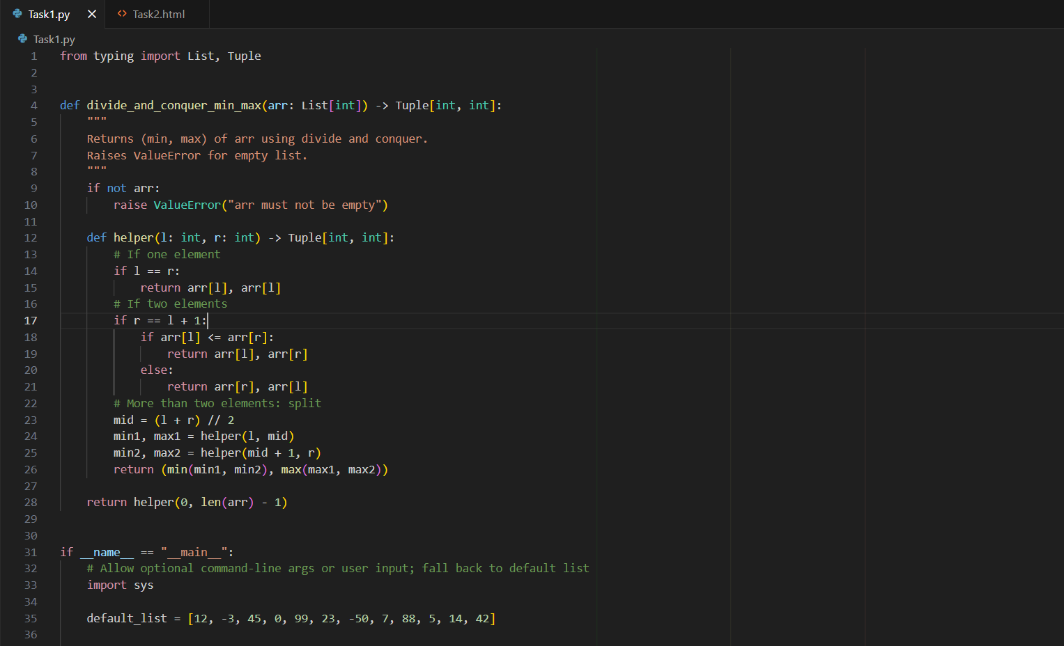
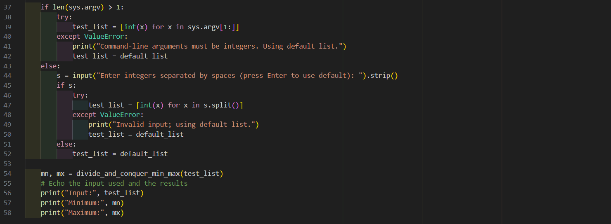
OUTPUT :
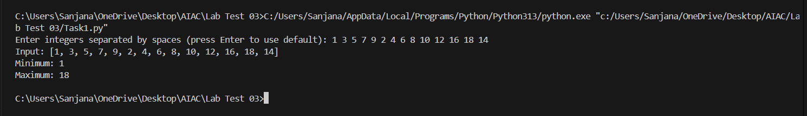

TASK 2 :
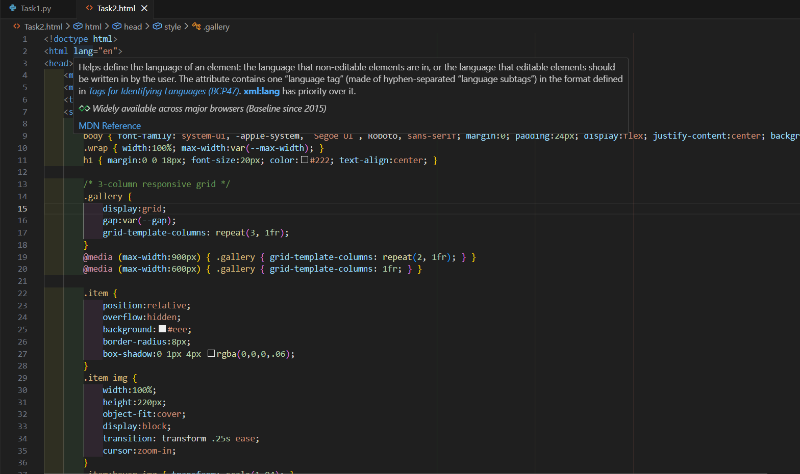
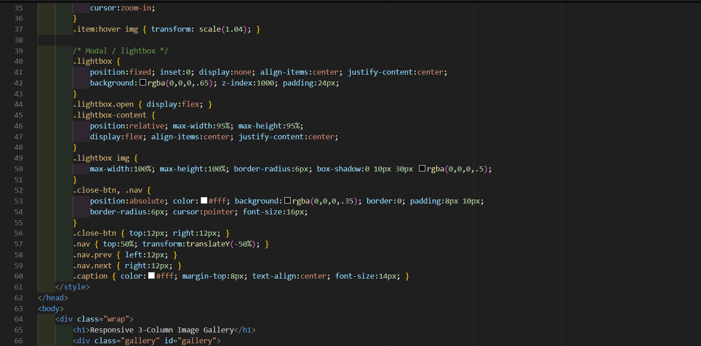
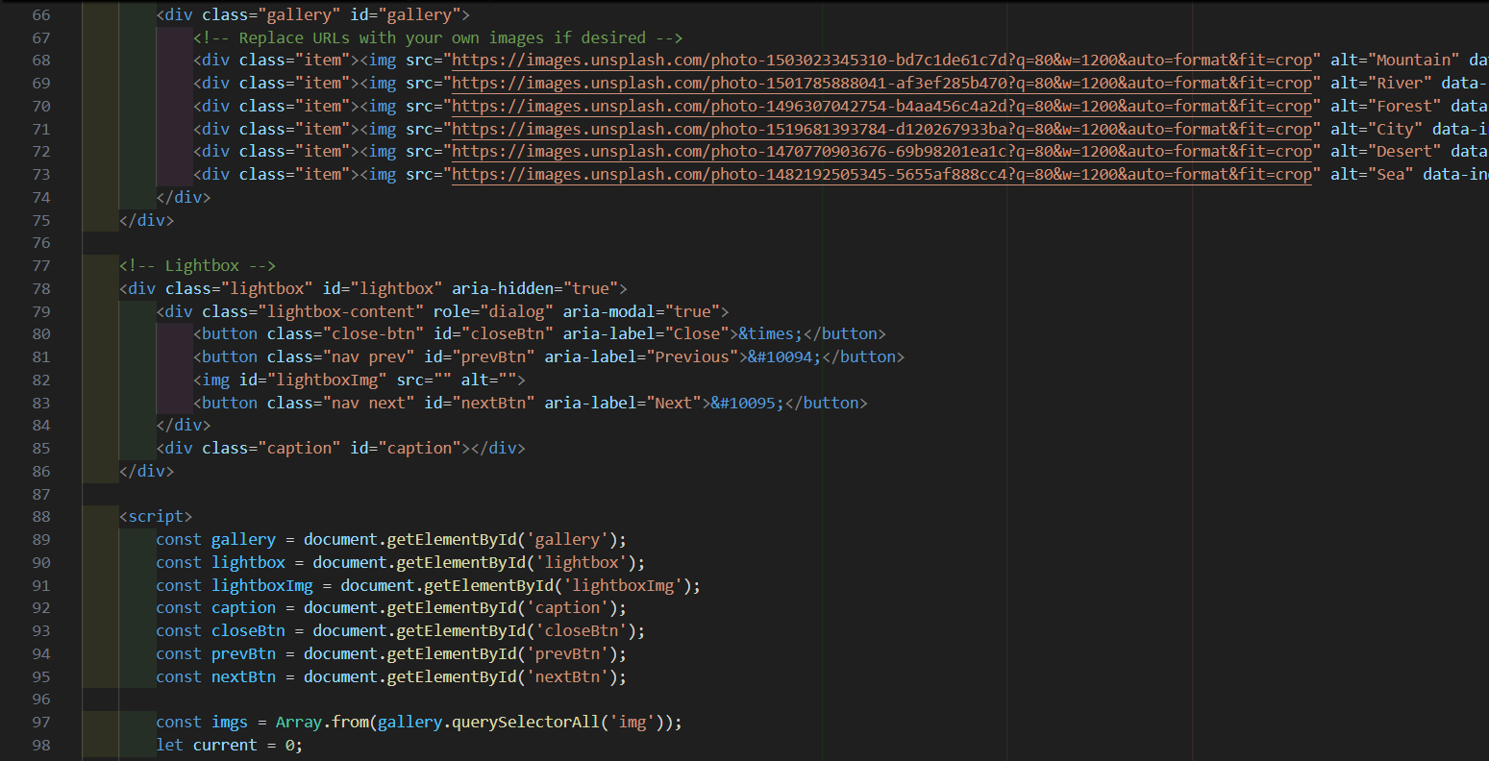
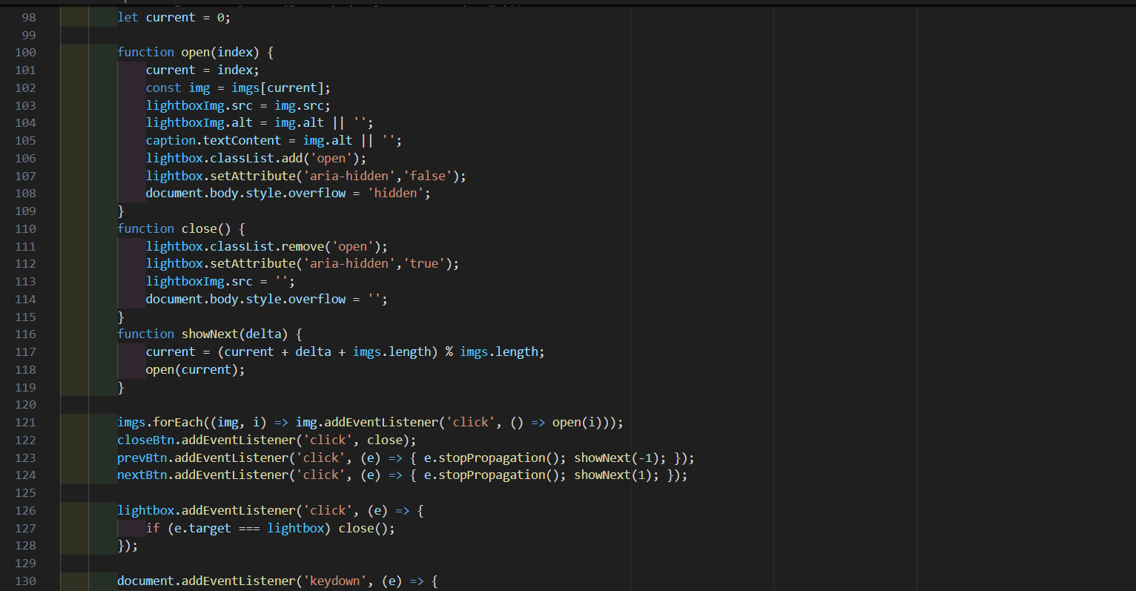
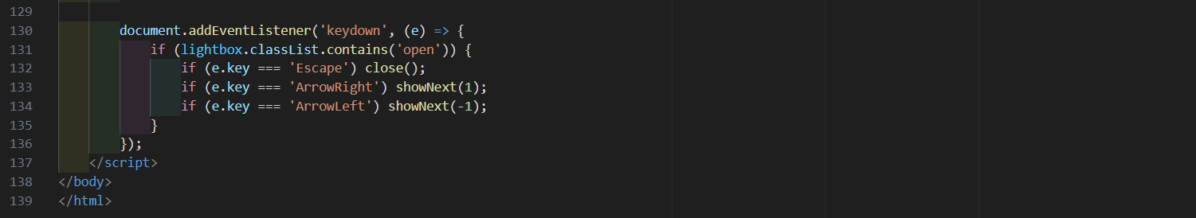
OUTPUT :
